
A Jewish Journey to Greece
May 24 – 31, 2027
Led by Rabbi Annie Tucker
Itinerary as of April 17, 2026 – Subject to Change

Monday May 24 The Jews of Athens
● Morning/Midday Arrival Athens
● One group bus transfer from the airport to the hotel, timed to the flight arrival time of most of the group
● Packed lunch
● Visit the Athens Jewish Museum, Synagogue and Shoah Memorial
● Group dinner with a member of the Athens Jewish community; learn about today’s Jewish community
Overnight: NYX Esperia Palace Hotel, Athens

Tuesday May 25 Classical Athens
● Breakfast at the hotel
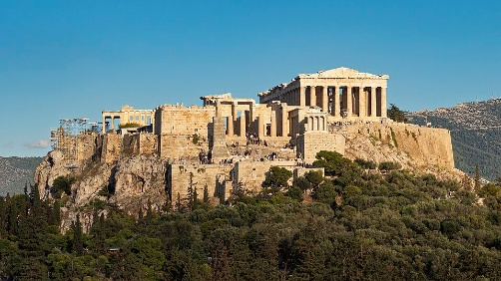
● See the ceremonial Changing of the Guard ceremony at the Tomb of the Unknown Soldier in Syntagma Square
● Guided tour of Classical Greek Athens sites including The Acropolis, Acropolis Museum, and the Ancient Agora
● Visit the Metropolitan Cathedral of Athens, the main Greek Orthodox cathedral in the city and the seat of the Archbishop of Athens and Greece
● Explore the open-air shopping markets
● Lunch and dinner on your own
Overnight: NYX Esperia Palace Hotel, Athens
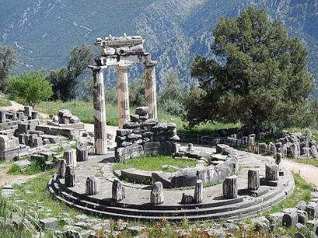
Wednesday May 26 Athens-Delphi-Larissa
● Breakfast at the hotel; pack bus and depart
● Head to the UNESCO World Heritage Site at Delphi where we will walk along the ancient Sacred Way which includes the Temple of Apollo and the Theater
● Lunch
● Continue north to Larissa. Many of Larissa’s 1,175 Jews were able to escape the Germans and join the Partisans.
● Dinner at the hotel
Overnight: Grecotel Imperial, Larissa

Thursday May 27 Larissa-Mt Olympus-Thessaloniki
● Breakfast at the hotel; pack bus and depart
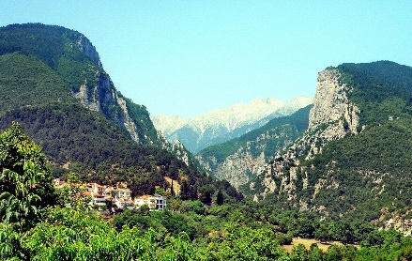
● Visit the beautifully restored Etz Hayyim Synagogue in Larissa which still serves the local community. Etz Hayyim is the only one of 7 pre war synagogues still functioning in Larissa. Meet a member of the Jewish community.
● Continue to Mt. Olympus National Park for some light nature walking
● Lunch on your own in picturesque Litochoro
● Continue to Thessaloniki. Tour Ano Poli (Upper Town) the only historic Thessaloniki neighbourhood to have survived the great fire of 1917.
●Check in at our hotel in central Thessaloniki
● Dinner on your own
Overnight: NYX Hotel, Thessaloniki
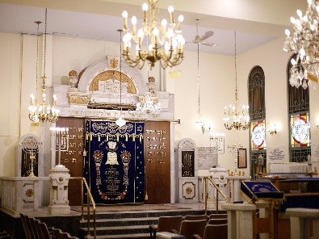
Friday May 28 Jewish Thessaloniki
● Breakfast at the hotel
● Visit the Thessaloniki Jewish Museum, Synagogue and Shoah Memorial. The Jews of Thessaloniki were the majority of the population for centuries. By 1940 the over 50,000 Jews of Thessaloniki made up 20% of the city. Almost all were murdered by the Germans.
● Lunch and shopping time of your own
● In the evening we’ll join the local Jewish community for Kabbalat Shabbat Services and Shabbat Dinner
Overnight: NYX Hotel, Thessaloniki
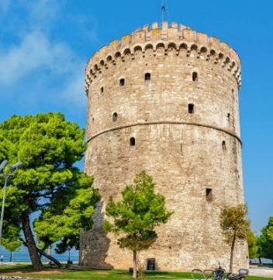
Shabbat May 29 Shabbat Shalom Thessaloniki
● Breakfast at the hotel
● Shabbat Services
● Shabbat Lunch at Chabad of Thessaloniki
● Afternoon walking tour along the seafront to the White Tower and the Alexander the Great Monument
● Evening and dinner on your own (Havdallah 9:32 PM)
Overnight: NYX Hotel, Thessaloniki

Sunday May 30 Veria & Vergina
● Breakfast at the hotel
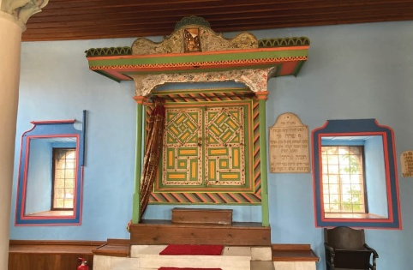
● Visit the Synagogue in the Old Jewish neighbourhood of Veria, where Jews lived from the days of the Second Temple. According to tradition, the synagogue stands on the same site as the ancient synagogue where the Apostle Paul visited nearly 2,000 years ago. Almost all of Veria’s 600 Jews were murdered by the Germans.
● Lunch on your own
● At Vergina, see the burials sites and treasures at the ancient Royal Macedonian Tombs, which includes burial mounds of Alexander the Great’s family
● Return to Thessaloniki for our Farewell Dinner
Overnight: NYX Hotel, Thessaloniki

Monday May 31
● Breakfast at the hotel
● One group bus transfer to Thessaloniki Airport timed to the flight departure time of most of the group
______________________________________________________________________________________________

Listed activities and speakers are subject to availability and confirmation. The trip will be staffed by a Keshet Tour Educator and local tour guides. All hotel breakfasts and underlined meals are included in the package price.


keshet@keshetisrael.co.il | www.keshetisrael.co.il

