Buenos Aires and the Iguazu Falls: Jewels of Latin America
March 8-16, 2027
Extension to Patagonia and Tierra del Fuegos: March 16-24
Led by Rabbi Jonathan Jaffe
Scholars in Residence: Rabbi Ernesto Yatteh, Yitzhak Sokoloff
Operated by Keshet Educational Journeys
April 1, 2026

Argentina boasts the largest Jewish population in Latin America, with over 180,000 Jews, making it the sixth-largest Jewish community in the world. The Jewish community in Argentina began with Spanish and Portuguese Jews in the early sixteenth century, including crypto-Jews, and grew with waves of immigrants from other countries in the 19th and 20th centuries. Buenos Aires features numerous synagogues, Jewish organizations, schools, and clubs, along with many kosher restaurants Additionally, Buenos Aires is home to world-class museums and significant Jewish remembrance sites.
During our stay we will immerse ourselves in the rhythm of "the Paris of South America”, experiencing the city's eclectic architecture and vibrant neighborhoods, filled with artsy cafes and street performers, including the Buenos Aires version of the Lower East side.
Led by Rabbi Jaffe, we will have a scholar in residence whose expertise is the Jewish community of Argentina. Together, we will also explore the rich Jewish heritage and vibrant culture of Buenos Aires, concluding our stay there with a memorable Shabbat as guests of two notable liberal congregations.

Our unique tour of Argentina concludes with two-day expedition to the spectacular Iguazu Falls Nature Park, which straddles the border of Argentina and Brazil. With more than 275 falls, Iguazu is one of the most impressive natural wonders of Latin American and the world.
Those who wish are welcome to remain for an optional extension to Patigonia will visit the world famous Perito Moreno Glacier and Tierra Del Fuego in the deep south of Argentina.

Monday, March 8- Late departure from JFK
- AA flight 953 departing JFK at 11:25 pm to Ezeiza International Airport (EZE) in Buenos Aires or Delta 115 departing JFK at 9:40 PM

Tuesday, March 9– Bienvenido a Buenos Aires! ברוכים הבאים לבואנוס איירס
- Land in Buenos Aires at 9:45 or 11: 15 am
- Introduction to our staff and bus tour through the city.
- Vegetarian Lunch in the beautiful Palacio Paz Restaurant, located in the Plaza de San Martin.
- Check-in and rest at our hotel in the beautiful Recoleta neighborhood.
- Tour of Recoleta, the Florida St. area or San Telmo.
- Orientation at hotel with Rabbi Ernesto Yattah.
- Dinner at the Sulam Club of the Sephardi Community.
Overnight: Alvear Palace Hotel, Recoleta (Buenos Aires) (or equivalent)

Wednesday, March 10 Buenos Aires- the vibe
- Visit to the Martin Buber School to meet with faculty and students.
- At Plaza de Mayo: explore the origins of Buenos Aires and the role of the Crypto-Jews in Argentinian history, the Metropolitan Cathedral, home to a unique Shoah Memorial and the site used by the "madres de plaza de mayo” to protest the “desaparecidos”(disappeared) during the military dictatorship of 1976-1983.
Lunch at the fabled El Galope Kosher Restaurant in the Once neighborhood, the local equivalent of the Lower East Side.
- Visit Templo Libertad, the first synagogue of Buenos Aires and the site of the Jewish Museum of Argentina.
- Visit the memorial created on the site of the former Israeli Embassy to Argentina, which was destroyed in 1992.

- Return to hotel to freshen up and enjoy the facilities.
- Tango lessons followed by dinner & Tango show
- Overnight: Alvear Palace Hotel, Recoleta (Buenos Aires)
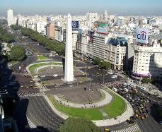
Thursday, March 11– Exploring Jewish Buenos Aires (2)
Briefing at the hotel with Eyal Sela, Ambassador of Israel to Argentina
- Visit the Holocaust Museum of Buenos Aires to learn about the kidnapping of Albert Eichmann and other aspects of the role of Argentina during and after WWII.
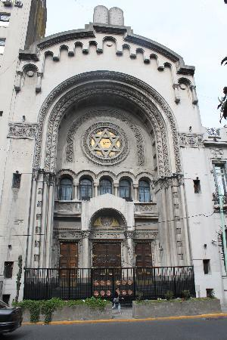
- Paso Synagogue, one of the oldest synagogues in Argentina which even has its own Tango orchestra
- Group lunch at Fuego Kosher Meat Restaurant in Once.
- Visit the AMIA, the headquarters of the Jewish Community of Buenos Aires and the site of a tragic episode in 1994.
- Cruise on the Río de la Plata River to the Tigre Delta, including a stop at the Koach Country Club
- Return to the hotel for dinner at leisure (or at Koach)
Overnight: Alvear Palace Hotel, Recoleta (or equivalent)

Friday, March 12 – Memories of a Dictatorship and the Legacy of Marshal Meyer
- Visit to the Yeshurun school and synagogue to meet the uniquely vibrant Syrian Jewish community of Buenos Aires.
- Visit the Museum of Memory for discussion on the dictatorship with a survivor of those dark days.
- Walking tour through the parks and coffee shops of Palermo with lunch at leisure
- Prepare for Shabbat.
- Candle lighting (6:35) and departure the hotel for a lively Kabbalat Shabbat with Congregation Amichai.
- Shabbat dinner with members of the congregation.
Overnight: Alvear Palace Hotel Recoleta (or equivalent)

Shabbat, March 13 Shabbat Shalom
- Optional Shabbat services at Beit Hasimha, a young and vibrant community of modern Orthodox Argentinians and Israelis or the Libertad Synagogue (Reform).
- Shabbat lunch with members of the congregation (at Beit Simha)- or free afternoon.
- Afternoon at leisure
- Processing Session followed by Havdalah.
- Dinner nearby our hotel with music from a local klezmer group
Overnight: Alvear Palace Hotel Recoleta (or equivalent)

Sunday – March 14 “There are No Words”!
- Breakfast, check out, and transfer to the domestic airport of Buenos Aires for our two-hour flight to Iguazu.
- Once we cross the Tancredo Neves Bridge into Brazil, our journey takes us into the Iguacu National Park in Brazil. The promenade unfolds, providing a comprehensive and breathtaking view of the Devil´s Gorge from Brazilian side.
- Kosher packed lunch (from Buenos Aires) or optional cafeteria style lunch at the Iguacu National Park.
- Return to the Argentinian side of the falls for transfer to our and check in.
- Dinner on own in the hotel or the city of Iguazu.
Overnight: Loi Suites Iguazu Hotel (or equivalent)

Monday March 15 Iguazu Falls from the Argentinian Side: The Great Adventure
- After breakfast, depart the hotel.
- Enjoy a scenic ride on the Ecological Train into the Iguazu National Park, which brings us to the Argentinean outlook over Devil’s Gorge, followed by a walk along the upper circuit of the fall, encompassing 6 magnificent viewpoints over the course of 1200 meters.
- Lunch on own in the park restaurant.
Afternoon Options (included)
- The Great Adventure! The Great Adventure is a unique experience, that combines jungle, rapids and cascades. In all terrain trucks the group will go through the jungle and then board semi-rigid speedboats to set sail on the lower Iguazu River. After crossing 2 miles of rapids, the boat enters the Devil’s Gorge Canyon and approaches the falls before circling back to bottom of the Lower Circuit. 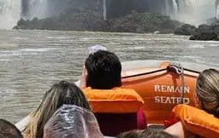

- OR: Lower Circuit: A mile long walking path of 1700 meters which brings us to panoramic views of the main falls, including the San Martin and the Bozzetti Falls.
Overnight: Loi Suites Iguazu Hotel (or equivalent)

For those returning to the US:

Tuesday – March 16 Adios u’Le’hitraot for those returning to the US
- Breakfast and transfer to the airport for the flight back to Buenos Aires domestic airport and transfer to Ezeiza International Airport for our return flight landing in JFK Airport on Wednesday morning. (Note that Delta passengers may have the option of flying back from the Foz do Iguacu International Airport via Sao Paulo (GRU).

For those continuing to Patagonia and the Deep South our once in a lifetime adventure continues.

Beth El Goes to Pategonia: Extension to the Glaciers of El Calafate and Tierra Del Fuego- “The End of the Earth”

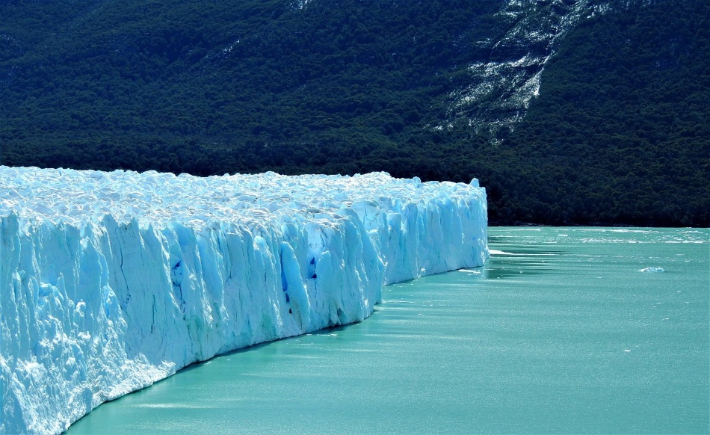

Tuesday March 16
● Breakfast at the hotel in Iguazu
● Morning departure for 10:30 flight to Buenos Aires and onward to El Calafate flight to El Calafate in the Argentinian South.
● 5:55 PM arrival in El Calafate
● Dinner in hotel or on your own in the town center (please let us know in advance)
Overnight: Xelena Hotel, El Calafate (or equivalent)

Wednesday March 17
● Breakfast at the hotel
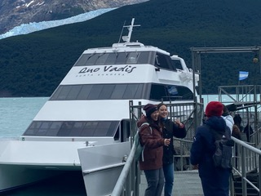

●Todo Glacier Boat Tour: Full Day Sail through the North Arm of Argentino Lake to Upsala Canal, and the Iceberg Barrier for a panoramic view of the Upsala Glacier. Cruise through the Spegazzini Canal, where we will see the Seco Glacier and the Spegazzini Glacier, the highest in the National Park. Then cruise through the Canal of Icebergs to the wall of the Perito Moreno Glacier Rupture.
Our group will receive “Captain’s Club” privileges, which include early boarding, preferred seating with a wonderful view, snacks, lunch (vegan option available) and the choice of beverages (minimum drinking age for this is 18).
● Return to Calafante for dinner and show at a local estancia (ranch)
Overnight: Xelena Hotel, El Calafate (or equivalent)

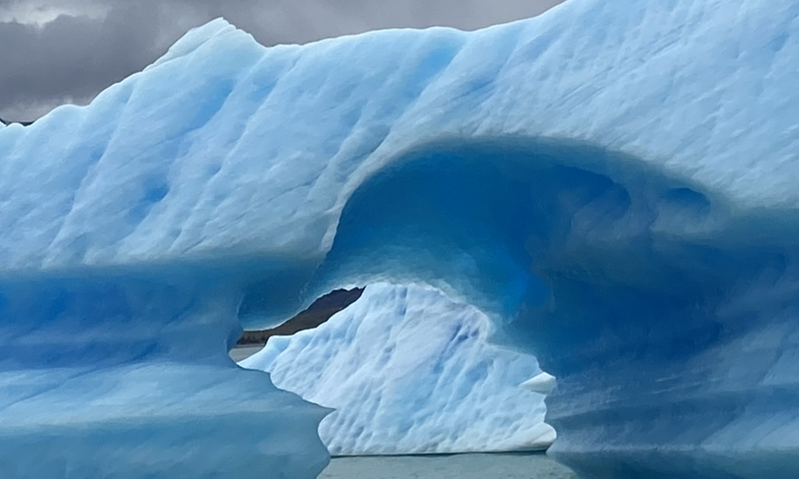

Thursday March 18
Breakfast at hotel
Check out and departure to the Moreno Glacier
- “Nautical Safari” excursion to the Perito Moreno Glacier on a catamaran vessel which gets as close as possible to the high walls of the glacier.
- 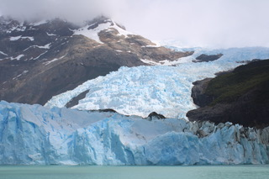

● Return to El Calafate for 4:45 PM flight to Ushaia. Arrive in Ushaia at 6:05 PM for transfer to the beautiful Arakur Resort and Spa.
Pool time and dinner
Overnight: Arakur Resort and Spa, (A “Leading Hotel of the World”) Ushaia, Argentina (or equivalent)

Friday March 19 To the Land of Fire
Breakfast at hotel
- Explore the Tierra Del Fuego National Park on a magnificent hike beneath the mountains and along the coast and a kayaking expedition.
- Private nautical cruise in the Beagle Strait linking the Atlantic and Pacific Oceans and free time in Ushaia, capital of Tierra Des Fuego, the jumping off point from Argentina to Antarctica.

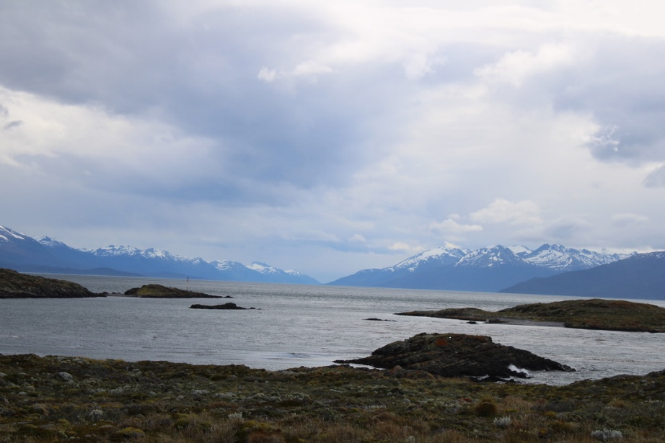

Return to our hotel to relax and prepare for Shabbat.
- “Beth El at the End of the World”- Kabbalat Shabbat together at the southernmost point in Latin America.
- Festive Shabbat dinner
- Overnight: Arakur Resort and Spa, Ushaia, Patagonia (or equivalent)

Shabbat March 20 R&R. מנוחת שבת
- Leisurely wake up and sumptuous breakfast
- Optional Shabbat services followed by a walk through the park that surrounds the hotel and Torah study, and time to take advantage of the hotel spa to its fullest.
- *Those who wish are welcome to order excursions through the hotel that range from helicopter rides over the mountains, horseback riding, and jeep rides and half day trip to “Penguin Island”
- Meet with Esteban Abolsky, President of Arakur Hotel and one of the 52 Jews to make their home in Tierra Del Fuegos (if available).
- Summary session and Havdala
- Final Dinner at Hotel
Overnight: Arakur Resort and Spa, Ushaia, Patagonia (or equivalent)
Sunday March 21 Hasta La Vista!
- Final dinner together in Buenos Aires.
- Morning flight to Buenos Aires and onward to New York

**Program is subject to change for reasons beyond our control, such as weather, airlines, or boat schedules.

Highlights of the Buenos Aires-Iguazu only option
all breakfasts, 2 Shabbat meals, 8-10 other meals (either kosher or with vegetarian options)
All transport and admissions as per itinerary
Domestic flight from Buenos Aires to the Iguazu Falls straddling Brazil and Argentina
Local guides in Buenos Aires and the Falls
Scholar in Residence to add unique expertise on Jewish aspects of Buenos Aires
Keshet and local logistics director to deal with local coordination and contingencies
3 nights five-star accommodations, 2 night 4 star
Shabbat Hospitality with congregations in Buenos Aires
Program on Argentinian history with a survivor of the days of the days of the dictatorship Keshet staff representative

Highlights of the Patagonia Extension
Local domestic flights
2 night in superior 4 star hotel in Calafate
3 nights in a super deluxe 5 star hotel within a nature preserve in Ushaia
1 Shabbat meal and final dinner included
Nautical tours of the El Calafate Glaciers and the Beagle Strait
Kayak or nature walk in the Tierra Del Fuego National Park Keshet and local logistics director to deal with local coordination and contingencies

