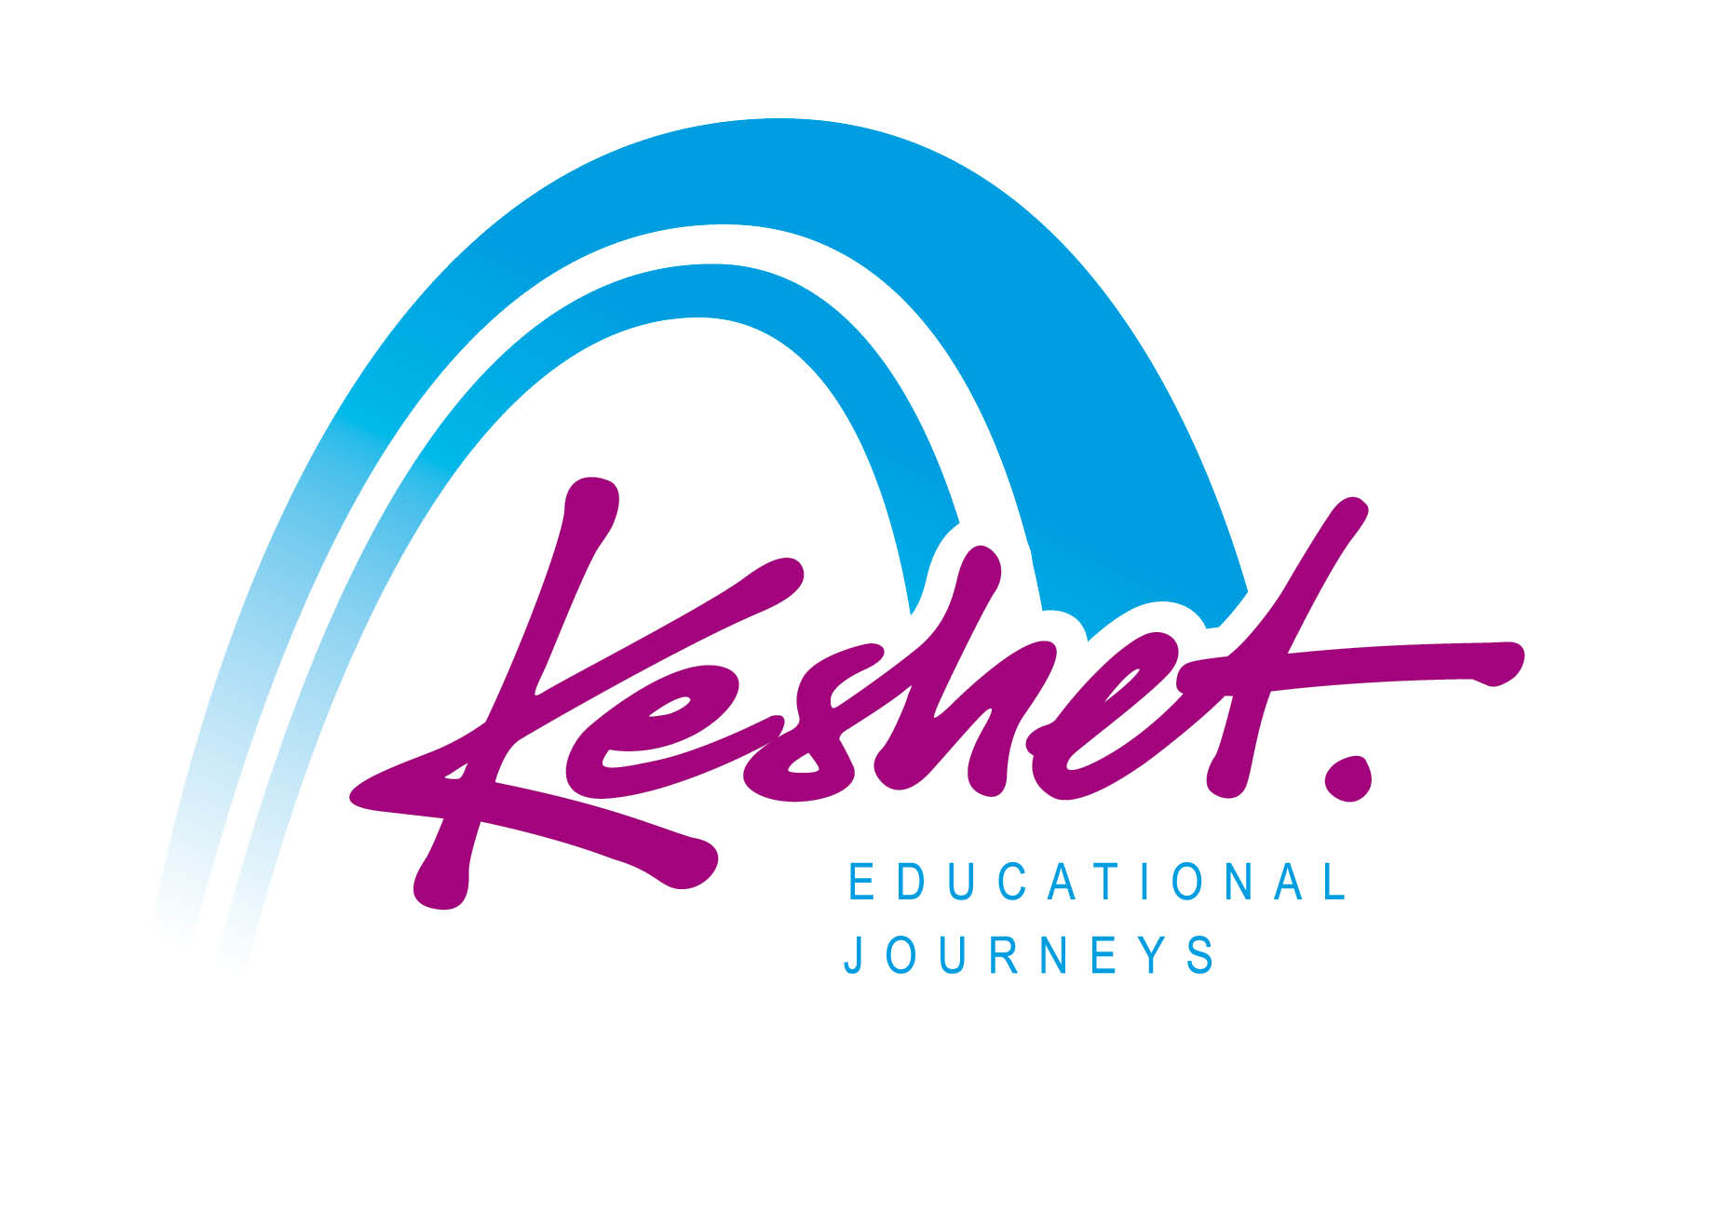

**Jewish Heritage Journey to Poland**

September 1- 9, 2025

*(Itinerary as of January 5 - Subject to Change)*

**Monday September 1**

* Check in at our hotel in Warsaw from 3:00 PM
* Opening dinner

**Overnight:** Westin Hotel,*Warsaw*

____________________________________________________________________________________________

**Tuesday September 2**

* Breakfast at the hotel
* At Warsaw’s **Okopowa Street** (Gensha) **Jewish Cemetery** we’ll learn about“The Life that Was”**.** Dating to 1799, it has over 200,000 graves and tells the story of Warsaw’s Jewish Community.
* Walk the **Memorial Route of Jewish Martyrdom and Struggle** in what had been the **Warsaw Ghetto** including UmshlagPlatz, Mila 18, and the Rappaport Memorial. *The 340,000 Jews of Warsaw made up about 1/3 of the city's population in 1939.*
* Lunch on your own *(Option to preorder and prepay for a Kosher packed lunch)*
* Visit the **Nozyk Synagogue**, the only synagogue in Warsaw to survive WWII
* Guided walking tour of **Warsaw’s beautifully restored Old Town.**
* Evening and dinner on your own.

**Overnight:** Westin Hotel,*Warsaw*

_____________________________________________________________________________________

**Wednesday September 3**

* Breakfast at the hotel 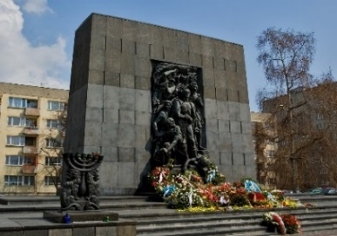
* See a remnant of the **Warsaw Ghetto Walls***.*
* Tour Warsaw's **Polin** **Museum of the History of Polish Jews.** The museum presents an overview of 1,000 years of Jewish history in Poland. *The 3.3 million Jews of Poland made up about 10% of the pre-World War II population of Poland*
* Lunch
* Continue to the site of the **Treblinka** Death Camp where over 870,000 Jews were murdered by the Germans, including most of the Jews of Warsaw.
* Return to Warsaw for evening and dinner on your own

**Overnight:** Westin Hotel, *Warsaw*

___________________________________________________________________________________

**Thursday September 4**

* Breakfast at the hotel
* Pack bus and depart
* Head to **Lublin;** prior to the Shoah the nearly 40,000 Jews made up over 30% of the city’s population.
* Lunch on your own (Option to preorder and prepay for a Kosher packed lunch)
* Guided walking tour of the beautifully preserved **Lublin Old Town** with a focus on the story of the Jews of Lublin
* Visit the restored **Chachmei Lublin Yeshiva** for a window into pre-war Jewish life (The Yeshiva - now the Ilan Hotel- was founded in 1930 by Rabbi Meir Shapiro to bring a new dignity and status to the study of Torah. Rabbi Shapiro also founded the Daf Yomi movement)
* Dinner
* Check-in at our hotel

**Overnight:** Mercure Unia Hotel,*Lublin*

**Friday September 5**

* Breakfast at the hotel
* Pack bus and depart
* 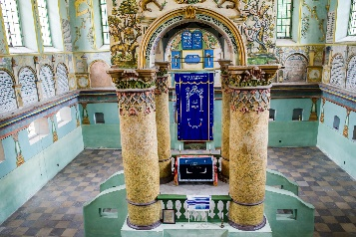Learn and remember at the site of the **Majdanek Concentration Camp**
* Packed Lunch
* Visit the beautifully restored 18th century synagogue in **Lancut,** home to 2,000 Jews before the Shoa
* Continue to Krakow for check-in at our hotel, just a few minutes’ walk from the magnificent medieval **Krakow Old Town Square**.

*Prior to the Shoah, there were 60,000 Jews in Krakow who made up 25% of the city’s population*

* Shabbat Candle lighting 6:57 PM
* Option for **Kabbalat Shabbat Services** at the historic Remuh Synagogue (Orthodox).
* Walk to the **Krakow Jewish Community Center** for **Shabbat Dinner** and to learn about Jewish life in Krakow today

**Overnight:** Holiday Inn City Center,*Krakow*

**Shabbat September 6**

* Breakfast at the hotel *(Served from 6:30 -10:30 AM)*
* 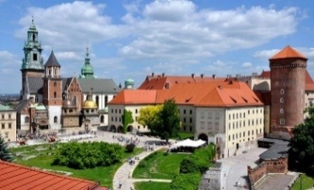Morning: Option to attend Shabbat Synagogue services or explore the city on your own
* Lunch on your own *(Option to preorder and prepay for a Kosher Shabbat lunch)*
* Afternoon: Guided walking tour at **Krakow Old Town Square** and the **Wawel Royal Castle,** once the residence of the **Kings of Poland** *and today the symbol of Polish statehood and one of the Poland’s premier art museums.*
* Evening and dinner on your own

**Overnight:** Holiday Inn City Center, *Krakow*

**Sunday September 7**

* Breakfast at the hotel
* 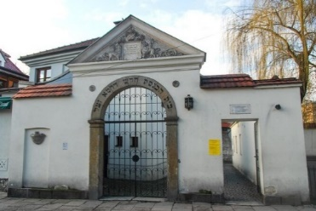At the **Kazimierz Old Jewish Quarter** of Krakow we’ll explore ***“The World That Was”.*** Sites include: Ramah Synagogue/Cemetery, Kupah & Temple Synagogues.
* Lunch on your own in Kazimierz
* Head to the Podgórze neighborhood of Krakow where the Germans established the **Krakow Ghetto.** *We’ll see a section of the* ***Ghetto Wall*** *and Zgody Square, now known as* ***Jewish Heroes Square.***
* Docent tour at the **Oskar Schindler Enamel Factory** exhibition:*Krakow Under Nazi Occupation 1939-1945.*
* Evening and dinner on your own

**Overnight:** Holiday Inn City Center, *Krakow*

**Monday September 8**

* Breakfast at the hotel
* 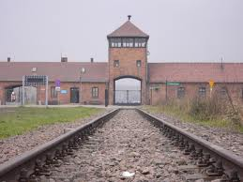7:30 AM – depart the hotel and head to the **Auschwitz**-**Birkenau** Polish State **Museum & Memorial**
* Start at the site of the **Auschwitz I Concentration Camp.** *Visit the barracks, museum exhibits and gas chamber.*
* Packed Lunch
* Continue to the site of the **Auschwitz II Birkenau Death Camp** where over 1,000,000 Jews were murdered.
* Return to Krakow –Closing dinner and trip summary session

**Overnight:** Holiday Inn City Center, *Krakow*

*______________________________________________________________________________*

**Tuesday September 9**

* Breakfast at the hotel
* Checkout by 11 AM
* Listed activities and speakers are subject to change.
* Underlined meals are included in the package price.
* All provided lunches and dinners will be kosher



**Keshet Educational Journeys**

PO Box 8540 Jerusalem 91084 Israel

Phone: 972-2-671-3518 | Fax: 972-2-671-3624

keshet@keshetisrael.co.il | www.keshetisrael.co.il