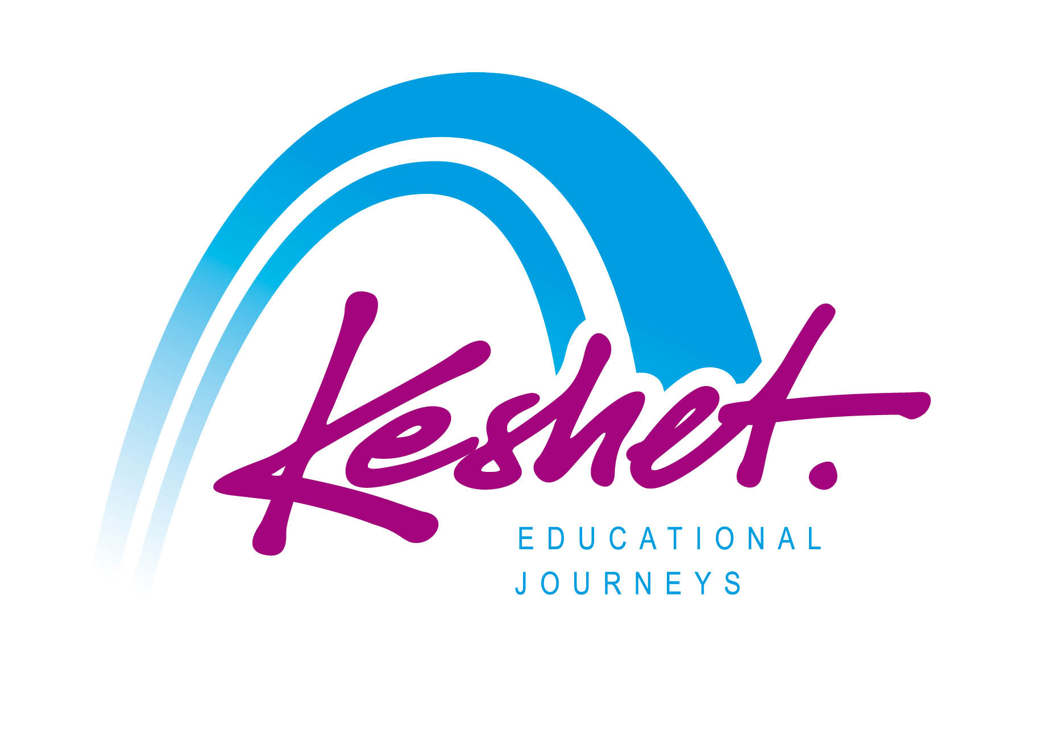

**Jewish Heritage Journey to Poland**

**May 4 - 11, 2026**

*With Optional Prague Extension May 11 - 14*

***FAQ***

**Q**: **Is this a Holocaust focused trip?**

**A:** The focus of the itinerary is the 1,000 year story of Jewish life in Poland )and Prague for those opting for the extension), past and present. We will get to know the Jewish “world that was” and meet members and leaders of today’s Jewish communities. The itinerary also includes visits to Polish heritage sites including the Wawel Castle and Old Town Square in Krakow, Old Town in Warsaw, Old Town Square and the Castle in Prague. While the fate of the Jews during the Shoah (Holocaust) looms large, it is not the sole focus of the trip

**Q**: **Is this a Jewish themed trip?**

**A:** Yes. We will be exploring Poland through the lens of the Jewish experience. It is however is open to all: Jews and non-Jews.

**Q**: **When and where does the tour begin and end?**

**A:** The trip will begin with our opening dinner Monday evening May 4 in Warsaw. The main trip will end on Monday morning May 11 with check-out from our the Radisson Blu Hotel in Krakow. The trip extension will end on Thursday morning May 14 with check-out from our The Hilton Old Town Hotel in Prague.

**Q**: **When should I arrive in Warsaw?**

**A:** The trip price includes accommodations at the Westin Hotel in Warsaw beginning on Monday May 4. We will be departing from the Westin Hotel at 6:00 PM for our opening dinner.

**Q**: **If I want to arrive in Warsaw prior to the date of the start of the trip or and/or stay in Krakow or Prague after the conclusion of the trip can Keshet arrange additional hotel nights for me?**

**A:** Yes – Keshet can arrange additional nights at the Westin Hotel in Warsaw prior to the start of the trip and/or at the Radisson Blu Hotel in Krakow or the Hilton Old Town in Prague after the conclusion of the trip, at additional cost and subject to availability. Please contact Keshet Logistics Coordinator Einav Kachalov [einav@keshetisrael.co.il](mailto:einav@keshetisrael.co.il) and she will be happy to check availability and price for you.

**Q**: **What about flight arrangements?**

**A:** Each trip participant will be making their own flight arrangements to arrive in Warsaw by Monday May 4 (or earlier) and to depart from Krakow on Monday May 11 or from Prague on Thursday May 14 (or later). If you need advice regarding flights, please contact Keshet Tour Educator Daniel Ehrlich at danny@keshetisrael.co.il

**Q**: **How about airport transportation in Europe at the beginning of and at the end of the trip ?**

**A:** Since each trip participant will be arriving and departing on their own schedule, the trip price does not include transportation from and to the airports. For transportation from Warsaw Chopin Airport to the Warsaw Westin Hotel you might find the airport website taxi information useful at the following link: <https://www.lotnisko-chopina.pl/en/taxi.html>

Additionally, the Keshet staff will be happy to arrange a pre-reserved, pre-paid airport transfer for you in Warsaw. Please contact Keshet Logistics Coordinator Einav Kachalov [einav@keshetisrael.co.il](mailto:einav@keshetisrael.co.il) and she will be happy to check availability and price for you.

**Q**: **Can additional touring and/or family roots explorations in Poland and the Czech Republic be arranged before the start of or after the end of the group trip itinerary?**

**A:** Absolutely. We can help you plan additional touring and/or family roots explorations in Poland before and/or after the trip or in the Czech Republic after the trip. Please be in touch with Keshet Tour Educator Daniel Ehrlich [danny@keshetisrael.co.il](mailto:danny@keshetisrael.co.il) who can help you to plan.

**Q: Will there be a lot of walking on the trip?**

**A:** Yes. We will be exploring Medieval city centers, castles, historic Jewish Quarters, memorials, museums and sites of German concentration and death centers – mostly on foot. There is no hiking in the itinerary and while we will walk at a normal pace, bear in mind that some of the historic areas have uneven paving such as cobblestones or dirt paths. There will also be opportunities to sit and rest, like on the bus between sites, at meals, etc. This physical pace of the trip is appropriate for participants using walking sticks and canes for additional support but not for those in wheelchairs or using walkers.

**Q**: **Can special dietary needs such as gluten free, vegetarian/vegan, kosher, allergies/food sensitivities etc be accommodated?**

**A:** Yes – absolutely. Keshet has a lot of experience in this area. The trip price includes regular breakfasts at each hotel (not under kosher supervision) which generally includes fruits, vegetables, fish, cereals, cheeses, yoghurts, eggs etc. There are kosher eateries in Warsaw, Krakow and Prague as well as vegetarian and vegan restaurant options. All provided lunches and dinners will be kosher. For meals are “on your own” our Keshet staff, local guides and hotel staff will assist you in finding the best places to eat.

**Q**: **Can Sabbath observance be accommodated on the trip?**

**A:** Yes. The Radisson Blu Hotel in Krakow is about a 20 minute walk from the synagogues and from the Krakow JCC where we will be having Friday night Shabbat dinner. There will be no group bus travel on Shabbat. A pre-ordered and pre-paid Kosher Shabbat lunch can be arranged.

**Q**: **Who will be leading and guiding the trip?**

**A:** Keshet’s Educational Director Danny Ehrlich will be the main tour educator. Danny has been organizing and guiding Jewish Heritage Trips to Europe for over 20 years and is one of the most experienced and dynamic guides in the field. He will be joined by a local guides and by specialty guides at various museums and sites.

**Q**: **How can I register for the trip?**

**A:** In order to reserve your place on the trip please complete the initial online registration form

[https://KeshetIsrael.formstack.com/forms/keshet_s_jewish_heritage_tour_to_poland_2026_registration_form](https://keshetisrael.formstack.com/forms/keshet_s_jewish_heritage_tour_to_poland_2026_registration_form)

**Trip size is limited to 25 people on a first-come, first-served basis, so the earlier you submit your registration the better.**

For full itinerary and pricing information click here: <https://www.keshetisrael.co.il/herpol>

Please feel free to contact us with any questions [danny@keshetisrael.co.il](mailto:danny@keshetisrael.co.il)

**Keshet Educational Journeys**

Jerusalem, Israel

keshet@keshetisrael.co.il | www.keshetisrael.co.il