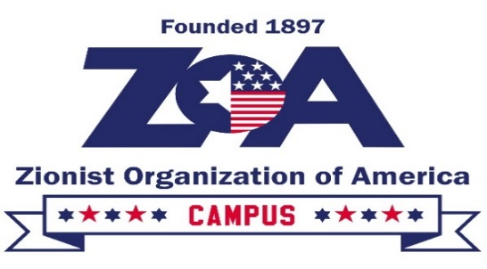
ZOA Student Leadership Mission to Israel
December 23-30, 2025
Code of Conduct and Statement of Responsibility

Please read the terms and conditions of this Code of Conduct and Statement of Responsibility carefully; they impose legal obligations on you. By signing this document electronically, you are signifying that you have read and understood all the terms and conditions, and agree to be legally bound by them.
The Zionist Organization of America (ZOA) Student Leadership Winter Mission to Israel 2024 is scheduled to take place from December 23, 2025 through December 31, 2025. In consideration of the ZOA’s payment of almost all the costs associated with my participation in the Mission, including up to $2000.00 of my roundtrip airfare to Israel, I hereby acknowledge and agree to the following:
1. I agree to be a productive member of the Mission and will conduct myself with responsibility, integrity, respect, pride, and industriousness, recognizing that I, and my conduct, should always reflect positively on the ZOA.

2. I will treat trip participants, trip staff, and any others with whom I interact with consideration, courtesy, and respect.

3. I will follow the instructions of the trip staff.

4. I will not engage in any activity that puts my safety or the safety of others in jeopardy.
5. I will remain with the group at all times unless I have prior permission from the trip staff to do otherwise.

6. I will observe all wake-up times and curfews.

7. I agree to attend and participate in all of the Mission’s activities, unless excused by the trip staff. I understand that the Mission itinerary may be subject to change and I agree to abide by it.

8. I will respect the property of others, including but not limited to the property at the temporary residences at which Mission participants will be staying. In the event that I cause damage to another’s property, I will pay the cost of repairing or replacing the property.

9. I will not engage in verbally or physically aggressive behavior.

10. I will not possess or consume any illegal substances, and I understand that there will be no tolerance for intoxication and/or intoxicated or disorderly conduct. I will not consume alcohol without the permission of the trip staff. I understand that drinking is only permitted in locations authorized by the trip staff, and only with their full knowledge and consent. I will not smoke indoors.

11. If, in the sole judgment of the trip staff, I have failed to abide by any of the foregoing standards of conduct, then I understand and agree that I may be immediately dismissed from the Mission, in which case I understand that I may, in the trip staff’s sole discretion, forfeit my $500.00 deposit and forfeit my $2000.00 flight subsidy. In addition, I agree to bear all costs and expenses resulting from my dismissal, including but not limited to the cost of travel to the airport and back to the United States.

12. I certify that I am in good physical condition and have no disease, injury, or other condition that would make my participation in the Mission hazardous, unwise, unwarranted, or a potential source of danger to me or others.

13. I understand that in addition to the strict security measures that the Israeli government takes to guard public places, the ZOA takes additional security precautions to ensure participants’ safety. I assume any and all risks associated with participating in the Mission. On behalf of myself, my heirs, next of kin, assigns, executors, administrators, and legal representatives, I release and forever discharge the ZOA, its officers, directors, agents, representatives, employees, assigns and subcontractors from any and all liability, claims, demands, actions or causes of action arising in any way from my participation in the Mission.

14. If I choose to extend my ticket to Israel, arriving in Israel before the start date of the Mission and/or remaining in Israel after the end date of the Mission, I understand and agree that this extension is independent of the ZOA and the Mission, and that therefore the ZOA is not responsible or liable for any claims, demands, actions or causes of action relating to said extension or to incidents that occur during said extension.

15. In case of injury, I authorize the ZOA to obtain medical treatment for me. I understand that I will be provided with medical insurance for the duration of the Mission, but that the ZOA is not responsible for any uninsured medical expenses. I further understand that I am solely responsible for obtaining travel insurance that can cover lost/stolen baggage and other person items.

16. I hereby give the ZOA permission to use and publish my name, my written and verbal comments about the Mission, and my image on the ZOA website and in any promotional materials prepared by or on behalf of the ZOA. I understand that the ZOA will not disclose my address, telephone number, or e-mail address on the website or in the materials, nor will said information be disclosed to third parties in the course of preparing the website or materials.

BY SIGNING THIS DOCUMENT ELECTRONICALLY, I AM INDICATING THAT I HAVE READ AND UNDERSTAND THIS CODE OF CONDUCT AND STATEMENT OF RESPONSIBILITY IN ITS ENTIRETY, AND HEREBY AGREE TO BE BOUND BY ALL ITS TERMS.

