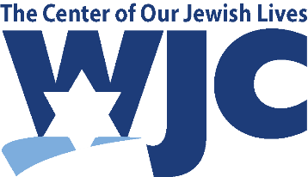

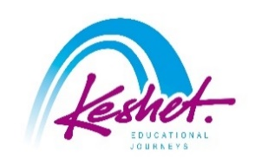
This Year in Israel!
Led by Rabbi Cornelia Dalton
July 27-August 3, 2026
updated September 25
Monday, July 27: | and we’re off!!
- Depart JFK – flights TBD

Tuesday, July 28: | Bruchim Habaim – welcome to Israel!
- Land in Tel Aviv in the morning
- Meet your guide, pack up the bus and start your exploration
- Volunteer at the Leket Distribution Center, which saves food from fields and events and sends it to those in need
- Lunch on own in the Sarona Foodie Market
- Peruse the crafts and enjoy the street performers at the renowned Nahalat Binyamin Arts and Crafts Fair and the adjacent Carmel Market
- Learn about the plight of the hostages at Hostage Square
- Dinner in a local restaurant
Overnight: Carlton Hotel, Tel Aviv

Wednesday, July 29: | A helping hand
- Agriculture volunteering in one of the villages affected by the aftermath of October 7th
- Pay your respects at the site of the Reim Supernova, where 364 party-goers and security forces killed
- See the collection of cars abandoned on October 7th and hear the stories connected to them
- Treat Israeli soldiers to a BBQ dinner and hear their stories
- Processing session
Overnight: Carlton Hotel, Tel Aviv

Thursday, July 30: | Tikkun Olam
- Bear witness to what happened on October 7th in Kibbutz Kfar Azza, where 64 residents were murdered and 19 were taken captive
- Volunteering opportunity in the town of Ofakim, a development town in which nearly 50 people were killed on October 7th
- Travel to Jerusalem
- Encounter in the Shalom Hartman Institute with a Hartman fellow on the situation in Israel today
- Check into your hotel, followed by a processing session and a free evening
Overnight: Inbal Hotel, Jerusalem

Friday, July 31: | this year in Jerusalem!
- Encounter at the hotel with Issam, a Palestinian who grew up in Gaza but fled and now lives in the West Bank; hear his point of view on the latest political situation in Gaza as he sees it
- Get an update on what has been happening in Israel since October 7th by a political analyst
- Support Israel’s economy on a shopping spree!
- Return to the hotel and prepare for Shabbat
- In the evening, participate in a group Kabbalat Shabbat at the pluralistic section of the Western Wall or overlooking it; then join the thousands of Israelis and Jews from around the world as they bring in Shabbat at the Western Wall
- Shabbat dinner in the hotel
Overnight: Inbal Hotel, Jerusalem

Saturday, August 1: | Shabbat Shalom
- Optional Shabbat services in a local synagogue or as a group
- Study session with Rabbi Dalton
- Shabbat lunch in the hotel
- In the afternoon, walk through the beautiful neighborhoods of Mishkanot Shaananim and Yemin Moshe, two of the first neighborhoods outside of the Old City Walls
- Free evening on town!
Overnight: Inbal Hotel, Jerusalem

Sunday, August 2: | taking it home
- Volunteer food packaging
- Visit the Mt. Herzl National Military Cemetery, including the graves of former Prime Minister Golda Meir, and fallen IDF hero, Hannah Senesh; pay your respects to those who have recently fallen protecting Israel
- Bikur Cholim – visit injured soldiers at one of the local hospitals and shower them with gifts
- Summary discussion
- Farewell dinner
- Transfer to the airport for your flight home

Monday, August 3: | Next year in jerusalem!
- Flight TBD
- Land in JFK
- Start planning your next trip to Israel!

- Listed activities and speakers are subject to confirmation.
- Program will be staffed by a Keshet Israel Tour Educator.
- All breakfasts plus underlined meals are included in the package price.
- This itinerary is proprietary to Keshet and is intended for the promotion of and to inform those considering joining this Keshet trip. It is not to be transmitted to any other party without prior authorization from Keshet

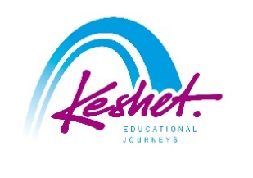
Keshet Educational Journeys
PO Box 52236 Jerusalem 9152102 Israel
keshet@keshetisrael.co.il | www.keshetisrael.co.il

